CS23633 – Cloud Computing Laboratory
EXPERIMENT 3
Aim:
To simulate a secure hybrid cloud connection between an on-premises data center and a cloud network using routers, switches, subnets, and routing in Cisco Packet Tracer.

Software Used:
- Cisco Packet Tracer
- Windows 11 (or your OS)

Network Topology:
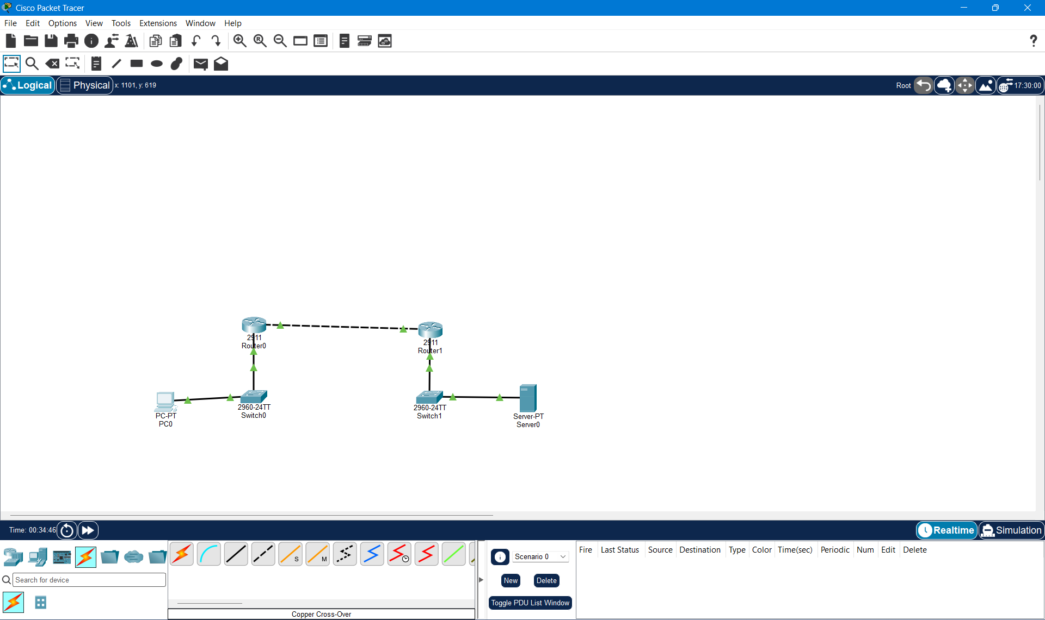
Hybrid cloud network topology.
- PC
- Switch0
- Router0
- Router1
- Switch1
- Server
- All green links

Router0 Configuration
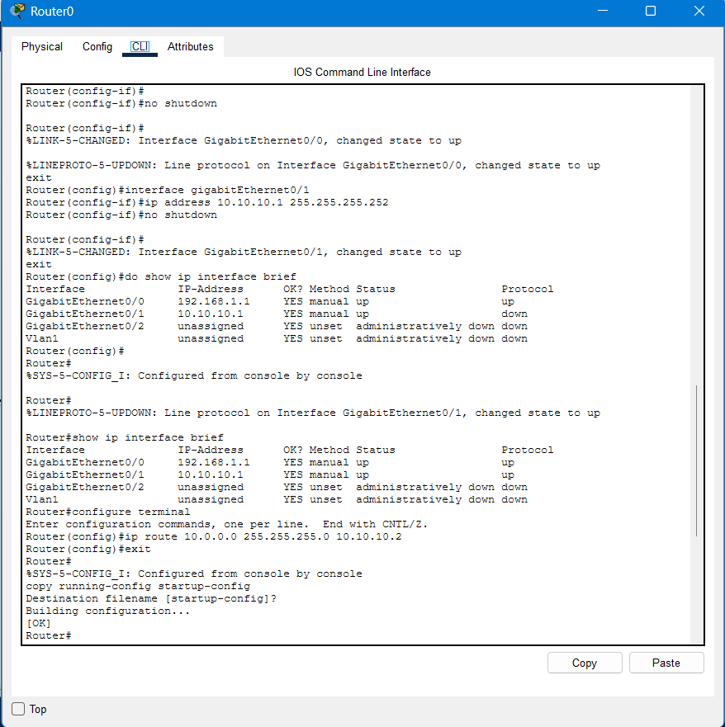
Router0 interface configuration.
Router1 Configuration:
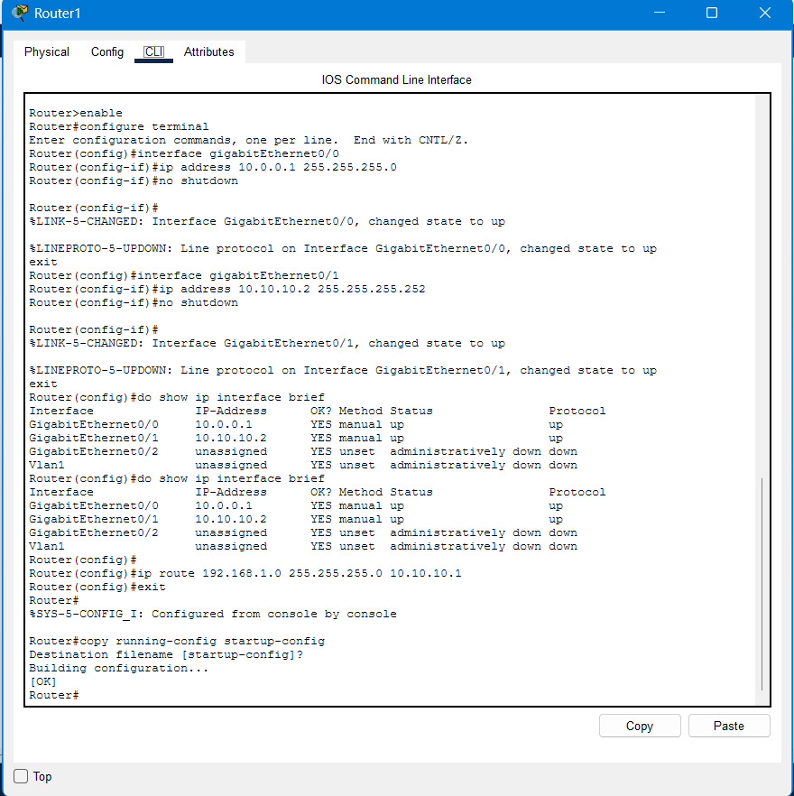
Router1 interface configuration.

PC Configuration:
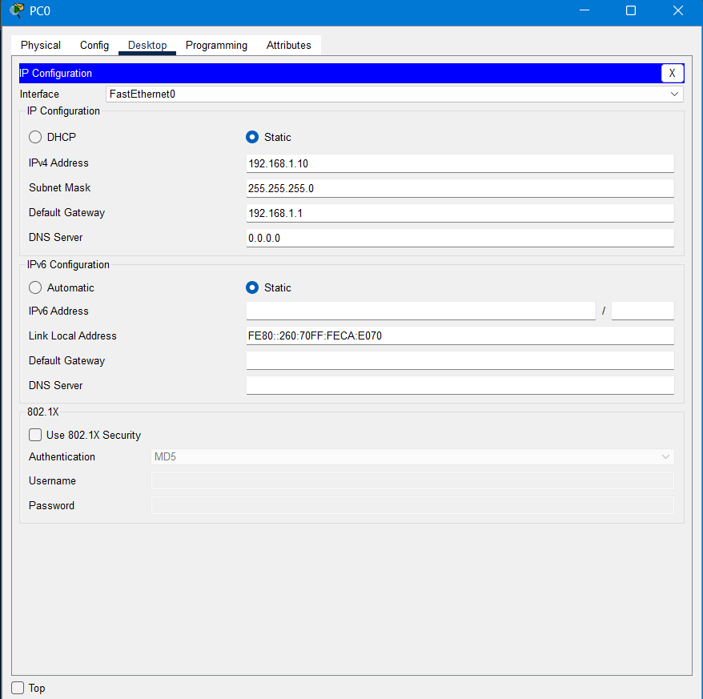
PC IP configuration.
Server Configuration:
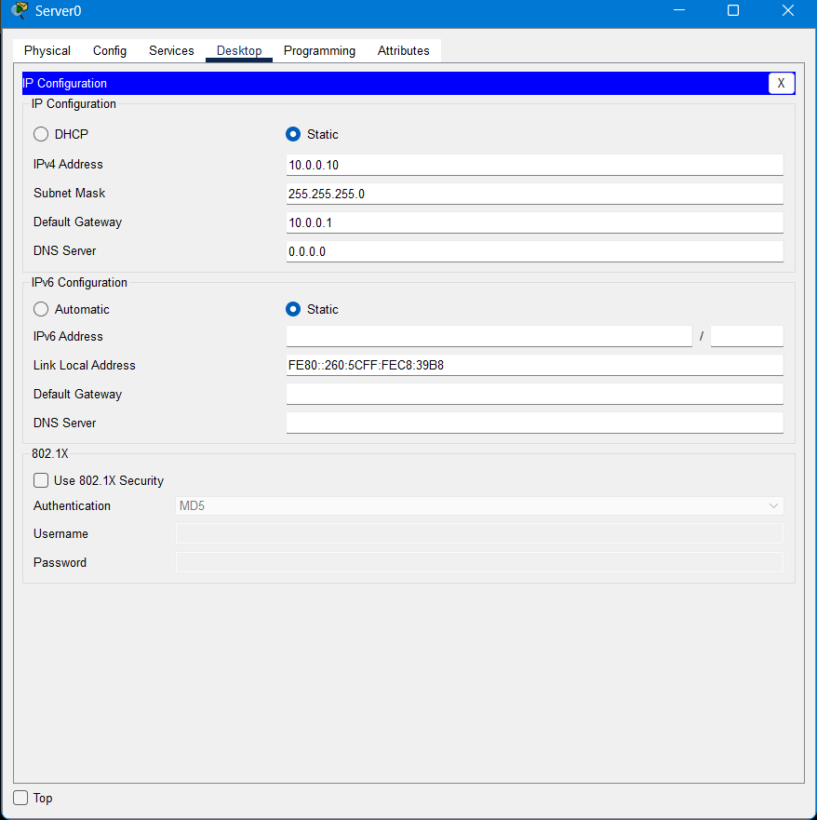
Server IP configuration.

Static Route Configuration:
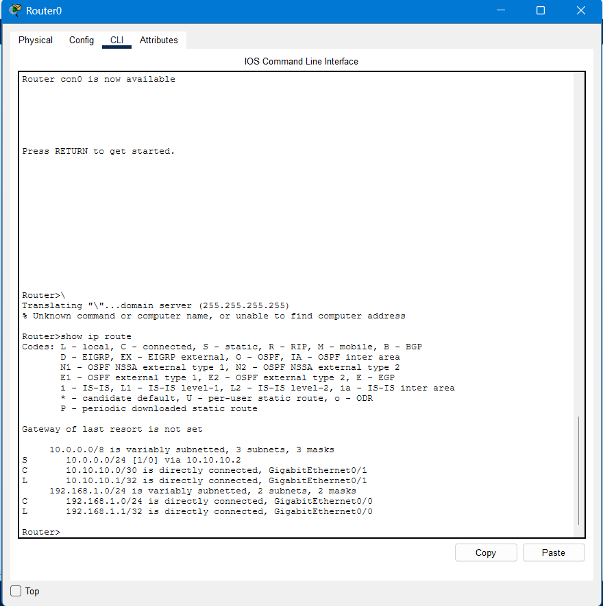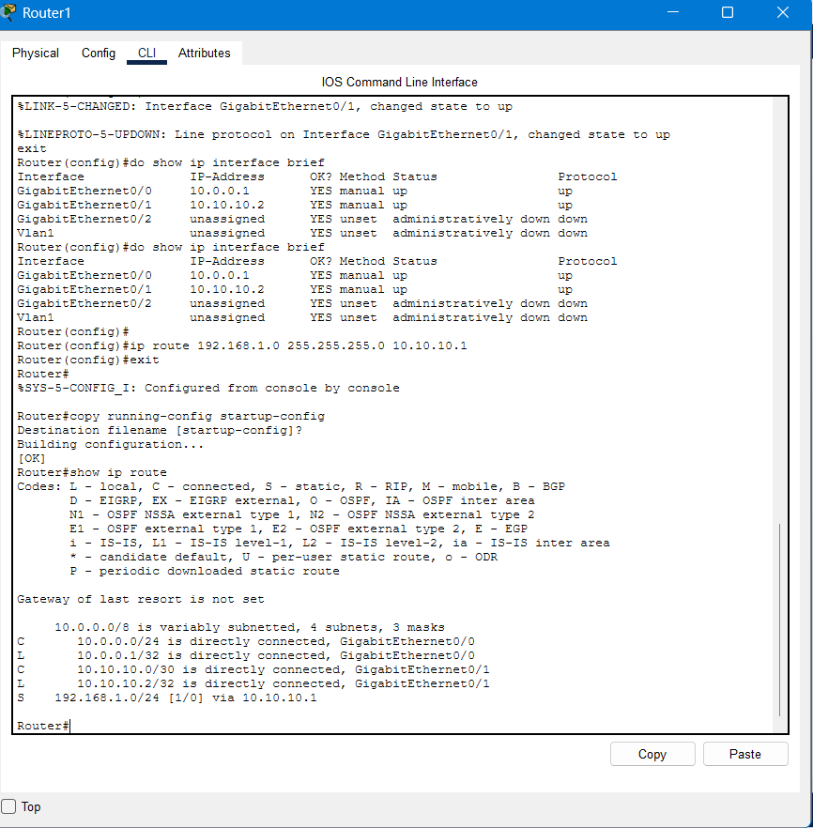
Static routing configuration.

Connectivity Test:
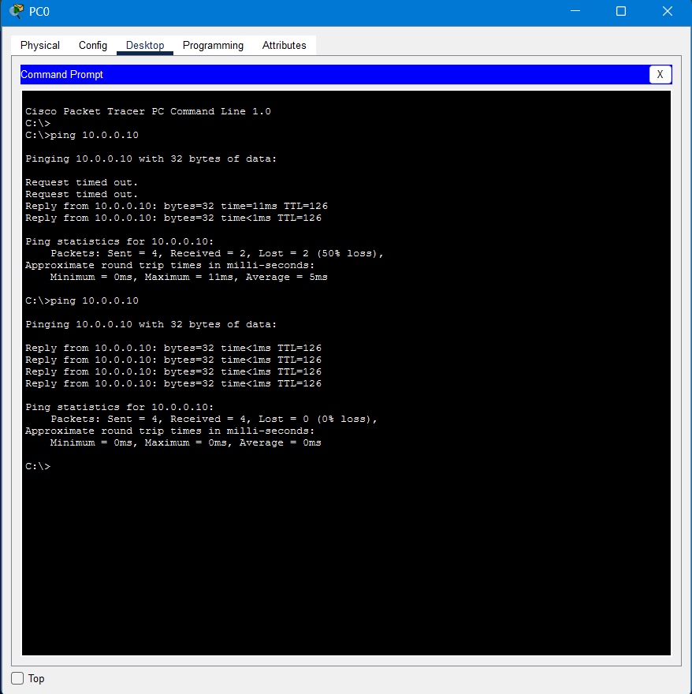
Successful ping from the PC to the cloud server.

Result:
The hybrid cloud network was successfully simulated using Cisco Packet Tracer. Two routers were configured with IP addressing and static routing to interconnect the on-premises network and the cloud network. End-to-end communication between the PC and the server was verified successfully using the ping command, confirming successful hybrid cloud connectivity.

